Ex.no:7a | DATA VISUALIZATION USING TABLEAU

Aim:
To connect, analyze, visualize, and create interactive dashboards using Tableau for effective business intelligence and data analytics.

Algorithm:
Algorithm: Student Performance Visualization using Tableau
Step 1: Data Loading
- Connect the synthetic Student Performance dataset to Tableau.
- Verify the imported fields: Student, Department, and Marks.
- The dataset contains six students: Arun, Bala, Divya, Priya, Ravi, and Karthik.
Step 2: Student Marks Bar Chart
- Create a worksheet for student-wise marks.
- Place Student on Columns.
- Place Marks on Rows.
- Select the Bar Chart visualization.
- Enable data labels to display the marks of each student.
Step 3: Department-wise Marks Visualization
- Create a worksheet using Department and Marks.
- Aggregate Marks using SUM.
- Visualize the contribution of each department using a Pie Chart.
- Display department names and corresponding marks as labels.
Step 4: Student Performance Trend
- Create a Line Chart using Student and Marks.
- Place Student on Columns and Marks on Rows.
- Enable labels to display individual marks.
- Use the chart to compare the performance of students.
Step 5: Marks Percentage
- Create a calculated field named Percentage.
- Use the formula:
[Marks]
- Display Student, Marks, and Percentage in a worksheet.
Step 6: Department Filter
- Add Department to the Filters shelf.
- Select a department such as AI&DS.
- Observe the updated student marks based on the selected department.
Step 7: Minimum Marks Parameter
- Create a parameter named Minimum Marks.
- Set the required minimum marks value.
- Apply the parameter to display only students whose marks meet or exceed the selected value.
- For example, when Minimum Marks = 85, display students scoring 85 or above.
Step 8: Dashboard Creation
- Create a new Tableau Dashboard.
- Add the Student Marks, Department Contribution, Marks Percentage, Student Performance Trend, and Minimum Marks visualizations.
- Arrange the worksheets clearly.
- Add the Department filter and Minimum Marks parameter.
- Format the dashboard with suitable titles and labels.
Step 9: Story Creation
- Create a Tableau Story using the completed dashboard.
- Add story points for:
  - Overall Student Performance
  - Department-wise Analysis
  - Top Performing Students
  - Final Performance Analysis
- Present the visual insights using the story.
Step 10: Analysis
- Analyze the charts to identify the highest and lowest performing students.
- Compare marks among departments.
- Observe how the Department filter and Minimum Marks parameter dynamically change the visualizations.
- Use the dashboard and story to summarize the overall student performance.
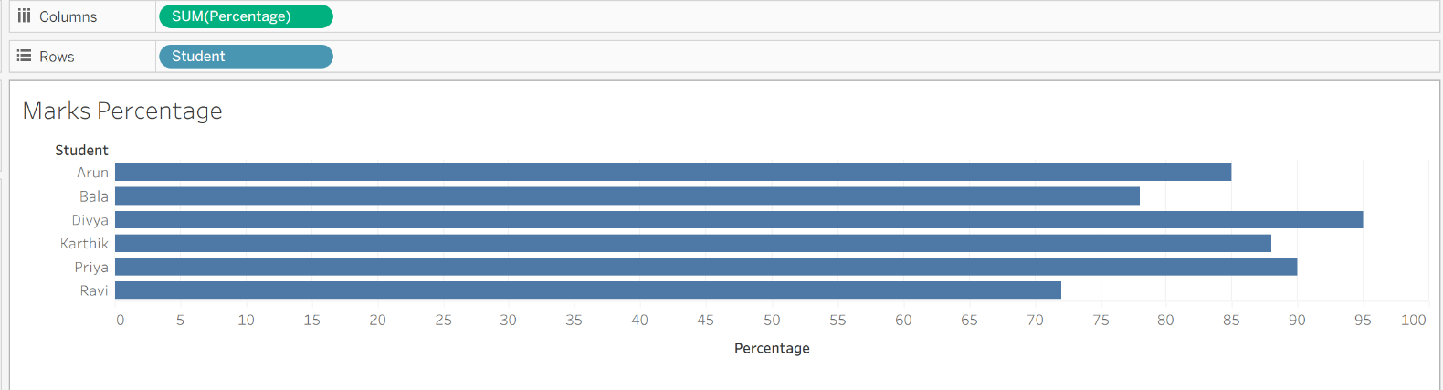
Output:

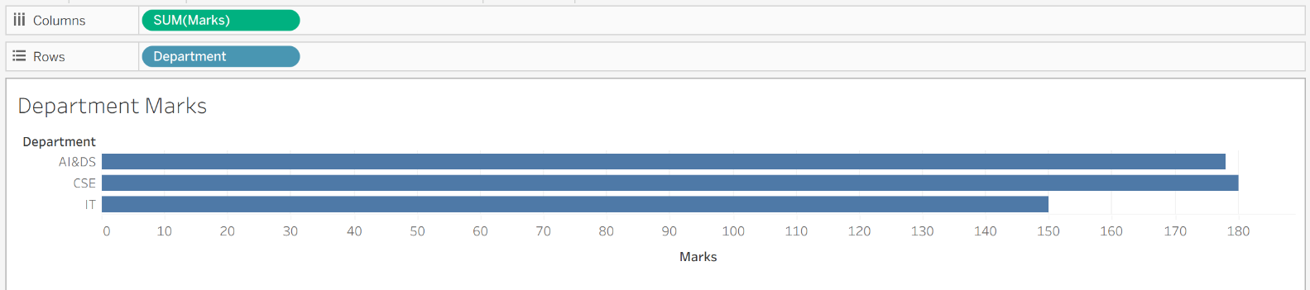

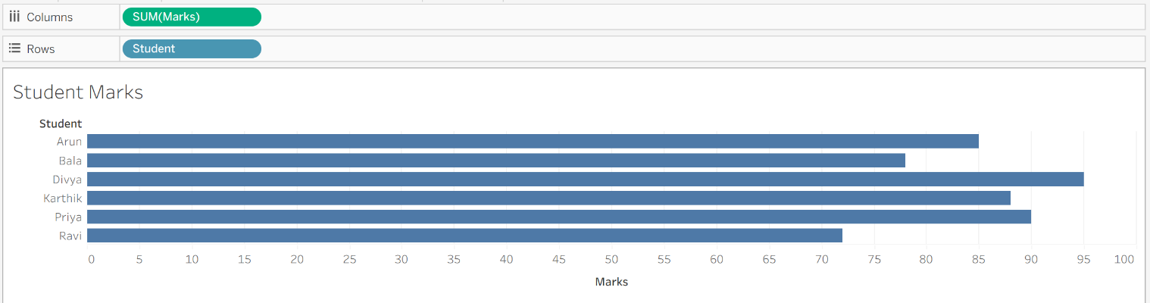

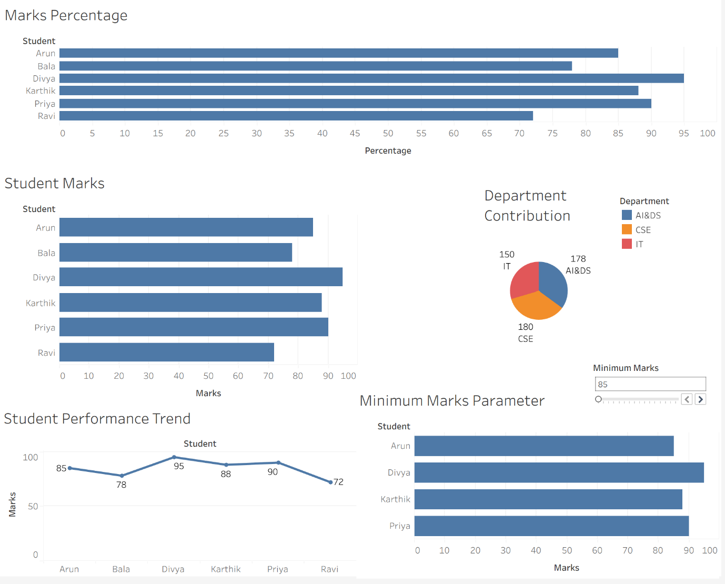

Result:

